10th INTERNATIONAL CHILDREN’S FOLK FESTIVAL
KIDS FUN FOLK 2019

12th – 16th of JUNE

2019
www.kidsfunfolk.pl
biurofestival@gmail.com
APPLICATION FORM

INFORMATION ABOUT THE FOLK GROUP
FULL NAME OF THE GROUP
COUNTRY
STREET AND NUMBER
CITY/TOWN
POSTCODE
TELEPHONE
MOBILE
E-MAIL
WEBSITE WWW
SOCIAL PORTALS (links)
BRIEF INFORMATION ABOUT THE GROUP (MAX.10 SENTENCES) | …………………………………………………………………………………………...  …………………………………………………………………………………………...  …………………………………………………………………………………………...  …………………………………………………………………………………………...  …………………………………………………………………………………………...  …………………………………………………………………………………………...  …………………………………………………………………………………………...  …………………………………………………………………………………………...…………………………………………………………………………………………...  …………………………………………………………………………………………...  …………………………………………………………………………………………...  …………………………………………………………………………………………...  …………………………………………………………………………………………...  …………………………………………………………………………………………...  …………………………………………………………………………………………...  …………………………………………………………………………………………...

INFORMATION ABOUT THE PARTICIPANTS OF THE GROUP
PARTICIPANTS BY REGULATIONS 25 PEOPLE

INCLUDING: DANCERS MUSICIANS DRIVERS LEADERS .GUARDIANS

ADDITIONAL PEOPLE – TOTAL NUMBER
(CHARGE 25 EURO/1 PERSON/DAY)

INCLUDING: DANCERS MUSICIANS GUARDIANS

DETAILS IN NUMBERS
GIRLS BOYS WOMEN MEN

LEADERS OF THE GROUP
NAME AND SURNAME OF THE LEADER
MOBILE
NAME AND SURNAME OF THE MUSIC DIRECTOR
NAME AND SURNAME OF THE CHOREOGRAPHER

PERSON TO CONTACT WITH THE GROUP
NAME AND SURNAME
MOBILE
E-MAIL

ADDITIONAL INFORMATION
MEANS OF TRANSPORT (TICK)

BUS PLANE ANOTHER (what?) ……………………………………………………………………..

DIETARY REQUIREMENTS

NUMBER OF PEOPLE DESCRIPTION OF DIET: ………………………………………………………………………………………………………………………………….
………………………………………………………………………………………………………………………………….
………………………………………………………………………………………………………………………………….
………………………………………………………………………………………………………………………………….

LIST OF MUSCICAL INSTRUMENTS:

- NAME ………………………………………………………………………….
- NAME ………………………………………………………………………….
- NAME ………………………………………………………………………….
- NAME ………………………………………………………………………….
- NAME ………………………………………………………………………….

After receiving an official invitation following promotional materials should be sent
for the address: biurofestival@gmail.com by 30 April 2019:
▪ 4 images (CMYK, JPEG or TIFF; minimum 1 MB),
▪ description of costumes provided for Exhibition of Folk Costumes,
▪ titles and description of artistic programs.
Filling and sending the Application Form means that we declare that we read the text of the Regulations of the International Children’s Folk Festival KIDS FUN FOLK Poznań 2019 and respect its regulations. It also means that we agree that the personal data of the group will be processed by the Festival Office for the Festival purposes.

………………………………………………………………………………..
Data and signature of the leader of the group

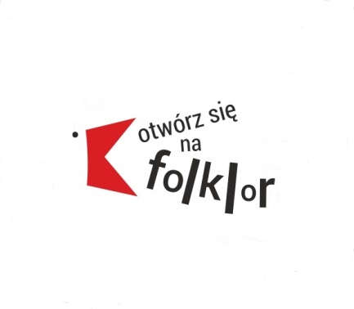
__________________________________________________________________________________________________________

Association of Folk Culture Sympathizers
„Live up to folk”
Poland, 61-214 Poznań, os. Powstań Narodowych 26/14;
e-mail: biuro@folklor.org.pl; www.folklor.org.pl
Alior Bank 52 2490 0005 0000 4500 9813 2305

